List to go

Name: Ahmed Mohsen, ID: AA2200061
Name: Seif Rami, ID: SR2200251
Name: Abdelrahman Elsayed, ID: AE2301057
Name: Mohamed Adel Assal, ID: MA2201152

Lecturer Name:
Dr. Marwa
Assistant Lecturer Name:
Dr. Shorouk

Table of Contents
Table of Figures 3
Introduction 4
Project scope 5
Requirements 6
Functional Requirements 6
Non-functional Requirements 6
Technologies and Tools Used: 7
Architectural design: 8
Product backlog: 9
Diagrams: 9
Manual Testing: 9
Automation Testing: 9
Risk Management: 9
GitHub Link: 9
Link to Trello: 9

Table of Figures

Introduction

This document’s purpose is to provide an understanding of technical and non-technical aspects of the web application. It will also document tools used and the decisions that team has made. It will also serve to ensure that customer requirements are met, such as guaranteeing the application’s ease of use and the inclusion of different themes.

Project scope

List To Go is a simple to do list application that emphasizes user friendliness and a smooth experience. It incorporates features that enhance the user’s task tracking, including deadlines, editing existing tasks, and monitoring task progress.
Additional features are also planned for release – Calendar view, task reminders, drag-and-dropping tasks, and automatically repeating tasks.

Requirements

Functional Requirements
- Login: Login Page that provides users to log in to their account
- Registration: Allow new users to create an account
- Scheduling: Allow users to add or delete tasks in their to-do list
- Statuses: add status to each task (Complete, Hold, Incomplete)
- Description: a small description of each task
- Sorting categories: Filter to sort task by date or any other category
- Priority: Mark each task by their importance and urgency
- Reminders : Reminder for the task before the due date
- Progression bar(optional) : A bar that would display progression
- Themes: Changing themes from light to Dark

Non-functional Requirements
- Modern Gui : User friendly UI & simple
- Efficiency: Speed of processes and time efficiency (completing requests)
- Encryption Data: Keeping data safe and secure from breaches
- Ethical implications: no use of data in an unethical method
- Security: Making sure security measures are put in place to keep users safe and anonymous
- Usability: Application will focus on all the user’s needs and the design will be user centered

Technologies and Tools Used:

The web application’s back-end is written in Django. This is mainly because of Django’s extensive documentation and wide usage. It also provides solid solutions and built-in functionalities. Django is also used to interact with the database.
The front-end, on the other hand, uses React due to the seamlessness of its user interface building. Like Django, it is also used commonly and well documented.
To link the back-end and the front-end, the front-end (React) sends requests to Django’s API. Afterwards, Django responds with either data or a status/error response.
Trello, a kanban-style task management application, is used to help keep team members up-to-date and help with task organization.
GitHub blah blah blah

Architectural design:

Product Backlog:

Sprint 1

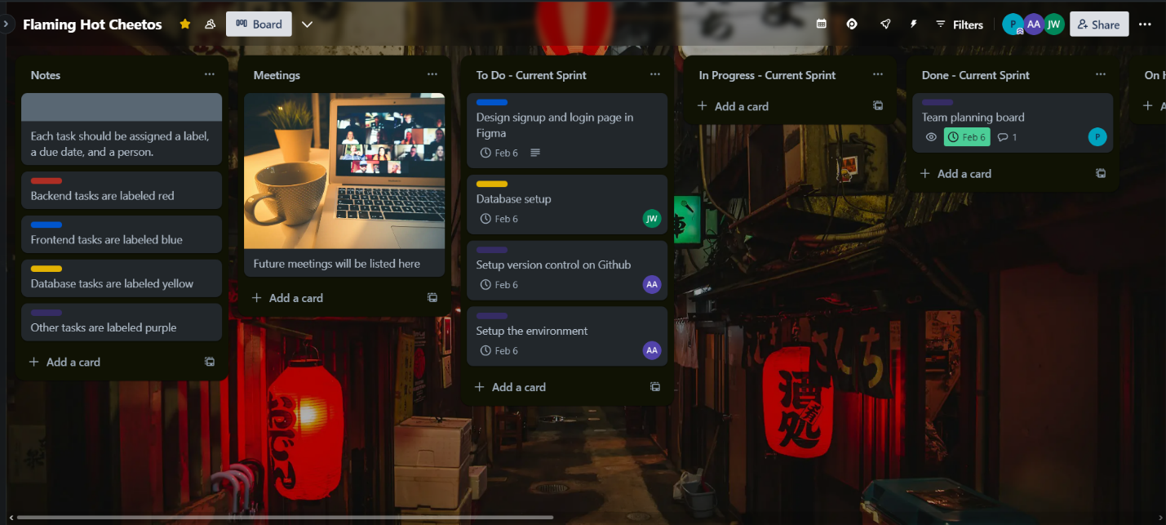

Sprint 2

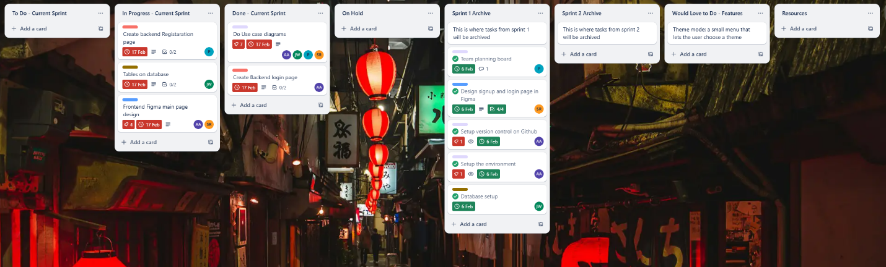

Sprint 3

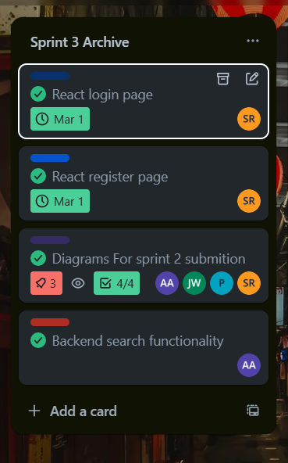

Sprint 4

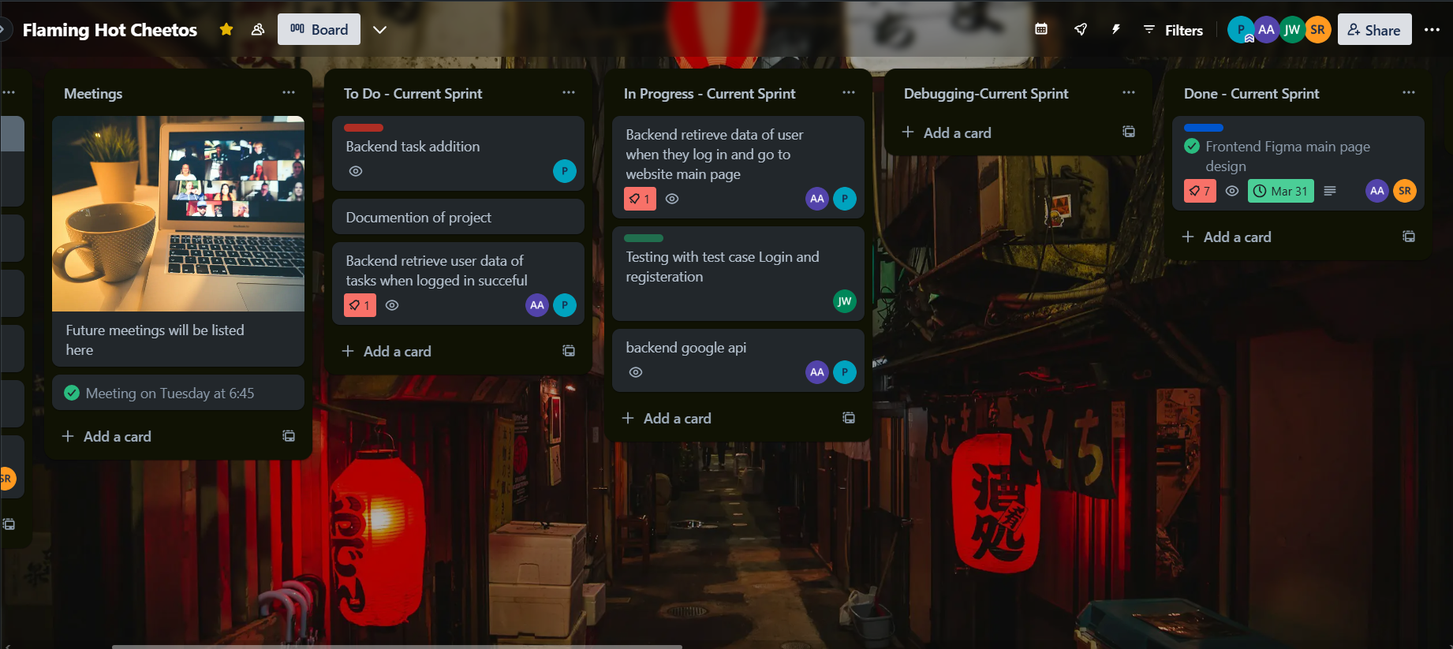

Diagrams:

Manual Testing:

Automation Testing:

Risk Management:

GitHub Link:

Link to Trello:

